Silicone Sheeting Selector Guide - Polymer Systems Technology Limited



UK & Ireland Distributor



© 2006 - Polymer Systems Technology Limited ™
Unit 2. Network 4. Cressex Business Park,
Lincoln Road, High Wycombe, Bucks. HP12 3RF
Phone +44 (0) 1494 446610
Fax: +44 (0) 1494 528611
Web: http://www.siliconepolymers.co.uk
Email: sales@silicone-polymers.co.uk
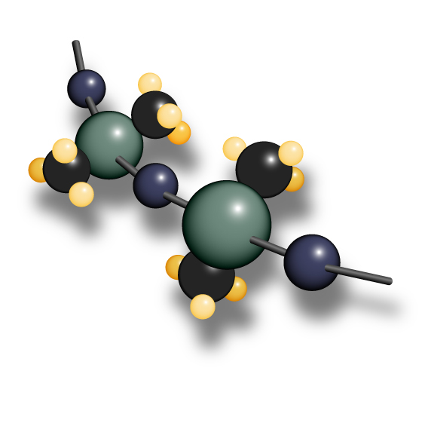
Silicone Sheeting Selector Guide
Polymer Systems Technology Limited

Polymer Systems Technology Limited now offers calendared sheeting products for Medical Applications. These sheeting products are broken into categories as listed below. Custom sheeting may be available upon special request.

Nomenclature: MEDAB-CD E F-GH
GH = Thickness in 0.001”
F = 0 for non-pigmented, 1 for pigmented (BaSO4)

E = 0 if unvulcanized, 1 if vulcanized
CD = Durometer, Shore A

AB = 90 Base, non-reinforced, unrestricted (for existing customers only)
AB = 91 Base, reinforced, unrestricted (for existing customers only)
AB = 92 Base, non-reinforced, unrestricted
AB = 93 Base, reinforced, unrestricted
AB = 82 Base, non-reinforced, restricted
AB = 83 Base, reinforced, restricted

Standard Sheeting Available by Category
Sheeting thickness are typically 9”x12” x Thickness. Most sheeting is made to order.

Product Name | Thickness | Durometer | Vulcanized | Reinforced | Price Category
MED82-5010-10 | 0.010” (0.25mm) | A-50 | Y | N | A
MED82-5010-15 | 0.015” (0.38mm) | A-50 | Y | N | A
MED82-5010-20 | 0.020” (0.50mm) | A-50 | Y | N | A
MED82-5010-25 | 0.025” (0.63mm) | A-50 | Y | N | A
MED82-5010-30 | 0.030” (0.76mm) | A-50 | Y | N | A
MED82-5010-40 | 0.040” (1.01mm) | A-50 | Y | N | A
MED82-5010-50 | 0.050” (1.27mm) | A-50 | Y | N | A
MED82-5010-60 | 0.060” (1.52mm) | A-50 | Y | N | A
MED82-5010-70 | 0.070” (1.78mm) | A-50 | Y | N | A
MED82-5010-80 | 0.080” (2.03mm) | A-50 | Y | N | A
MED82-5010-XX | Custom | A-50 | Y | N | A
MED82-5011-XX | Custom | A-50 | Y | N | B
MED83-5010-XX | Custom | A-50 | Y | Y | B
MED83-5011-XX | Custom | A-50 | Y | Y | C
MED92-5010-10 | 0.010” (0.25mm) | A-50 | Y | N | D
MED92-5010-15 | 0.015” (0.38mm) | A-50 | Y | N | D
MED92-5010-20 | 0.020” (0.50mm) | A-50 | Y | N | D
MED92-5010-25 | 0.025” (0.63mm) | A-50 | Y | N | D
MED92-5010-30 | 0.030” (0.76mm) | A-50 | Y | N | D
MED92-5010-40 | 0.040” (1.01mm) | A-50 | Y | N | D
MED92-5010-50 | 0.050” (1.27mm) | A-50 | Y | N | D
MED92-5010-60 | 0.060” (1.52mm) | A-50 | Y | N | D
MED92-5010-70 | 0.070” (1.78mm) | A-50 | Y | N | D
MED92-5010-80 | 0.080” (2.03mm) | A-50 | Y | N | D
MED92-5010-XX | Custom | A-50 | Y | N | D
MED93-5010-XX | Custom | A-50 | Y | Y | E

Non-Standard Sheeting Available by Category

Product Name | Thickness | Durometer | Vulcanized | Reinforced | Price Category
MED90-5000-10 | 0.010” (0.25mm) | A-50 | N | N | D
MED90-5000-20 | 0.020” (0.50mm) | A-50 | N | N | D
MED90-5000-30 | 0.030” (0.76mm) | A-50 | N | N | D
MED90-5000-40 | 0.040” (1.01mm) | A-50 | N | N | D
MED90-5000-60 | 0.060” (1.52mm) | A-50 | N | N | D
MED90-5010-10 | 0.010” (0.25mm) | A-50 | Y | N | D
MED90-5010-12 | 0.012” (0.30mm) | A-50 | Y | N | D
MED90-5010-60 | 0.060” (1.52mm) | A-50 | Y | N | D
MED91-5000-10 | 0.010” (0.25mm) | A-50 | N | Y | E
MED91-5000-20 | 0.020” (0.50mm) | A-50 | N | Y | E
MED91-5000-30 | 0.030” (0.76mm) | A-50 | N | Y | E
MED91-5000-40 | 0.040” (1.01mm) | A-50 | N | Y | E
MED91-5000-60 | 0.060” (1.52mm) | A-50 | N | Y | E
MED91-5010-10 | 0.010” (0.25mm) | A-50 | Y | Y | E
MED91-5010-20 | 0.020” (0.50mm) | A-50 | Y | Y | E
MED91-5010-40 | 0.040” (1.01mm) | A-50 | Y | Y | E
MED92-8010-15 | 0.015” (0.38mm) | A-80 | Y | N | D
MED92-8010-18 | 0.015” (0.38mm) | A-80 | Y | N | D

Pricing Schedule End User Pricing
A £55/sheet
B £65/sheet
C £75/sheet
D £95/sheet
E £105/sheet
F £115/sheet

- Customization or special requests will be accepted on a case by case basis, and require a £1500 Development Fee.

- The sheeting will be made from materials that already have masterfile and compendium support.

- Tolerances on sheeting thickness are typically +/- 10% thickness values.

- Durometer measurements are made on the base material per NuSil TM006.

- Combination sheeting of Vulcanized on 1 side and Unvulcanized on the other side will be priced as 2 separate sheets. All applications of this type must be quoted prior to development, and will be made to order.

- Double reinforcement with Polyester mesh is available upon request as a custom product.
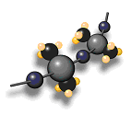
- Different Durometers between 30-80 Shore A may be developed upon request from standard base HCRs for £500 set up fee. Durometers below 30 may be too soft to run on the equipment, but may be evaluated as a custom development request for £1500 or more, depending on the complexity of the application.

- All pricing is subject to Polymer Systems Technology Limited Terms & Conditions.

Last updated: 03/07/2006

